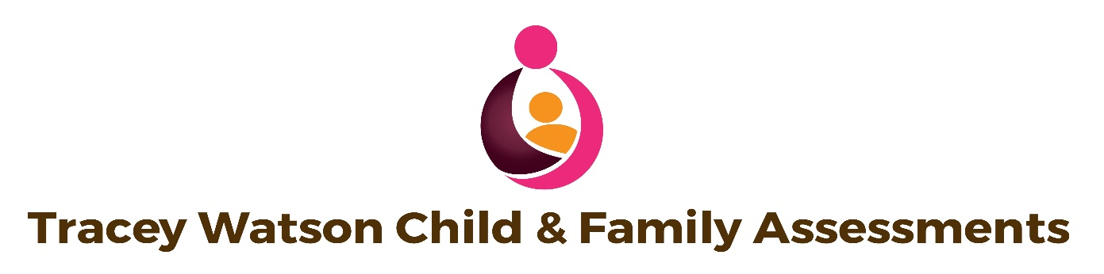
CURRICULUM VITAE
Tracey Watson
Independent Child Care Consultant
07746190085
tracey.mysocialwork@outlook.com
mysocialwork.co.uk

Qualifications:
Diploma in Social Work
PAMS 4.0
ParentAssess
Profile

I am an Independent Social Work practice, which has been operating as an entity, as not just an expert witness, but also as a practitioner within Childcare assessments since 2015. I have over 18 years’ post qualification experience, in addition to having worked in children’s residential care for 4 years, working with children with complex behaviour and attachment difficulties. I have worked exclusively in the field of Child Protection, as a Frontline Child Protection and Foster Carer social worker, Family Court Advisor, Independent Reviewing Officer, and Child Protection Conference Chair. Since 2015, I have practiced as an Independent Social Worker and Expert Witness.

As an Independent Social Worker, I am able to offer a range of assessments including Risk and Parenting Assessments, Assessments using the PAMS software, ParentAssess using the ParentAssess software, Section 7 and Parenting, Viability and Sibling Assessments and Special Guardianship Order Assessments.

In addition, I am also ;
- experienced in Family assessments where domestic abuse, substance misuse, mental health, sexual risk or learning difficulties is a factor.
- extensive experience of working directly with children and young people in an effective and sensitive manner in order to ascertain their wishes and feelings and accurately report the same to the court.
- experience in working with children and families from the different faiths and cultures that are represented in the North-West and New Zealand and wide experience of working with interpreters.
- observation of children with their parents in order to assess parental capacity and attachment.
- facilitation and participation in family group conferences, care planning meetings, looked-after children reviews and child protection case conferences.
- excellent up to date working knowledge of childcare legislation and this has underpinned my practice.
- Promoted, audited and monitored adherence to Child Protection procedures from referral of suspected abuse to ensuring the child is safeguarded with use of the Issues resolution process.
- Quality assurance and audits.
- Case monitoring, guidance and support of social workers.
- Permanence Planning and Pathway Planning for care leavers.
- Safety Assessment work with adults and adolescents with sexualised behaviour.
- Identification of foster carers training needs/supervision of foster carers and appropriate matching.
- Devising and presented training for foster carers and applicants to be caregivers, training including, behaviours associated with abuse; Pathways into Care and Legal Issues.
- Attended Privacy and Official Information training and processed requests from Council for Child; Police and individuals wishing to access a child or their own file.

I am registered with the Health and Care Professionals Council, The British Association of Social Workers (BASW), Nagalro and registered under the Data Protection Act.

Professional Experience

2000 - 2004 | Residential Social Worker  Private and various Local Authority Children’s Homes contracts  Team Leader and Assistant Manager
July 2004 – December 2005 |  | Child Protection Social Worker Team  North-West Local Authorities
December 2005 – May 2008 |  | Child, Youth and Family New Zealand Referral and Assessment Team and Foster care Social Worker
May 2008 – April 2011 |  | Child Protection Social Worker  Child Protection Team  North-West Local Authorities.
April 2011-December 2011 |  | CAFCASS  Early Intervention Team / Family Court Advisor
January 2012 - December 2013 | Child Protection Social Worker  Child Protection Team  North-West Local Authorities.
Jan 2014 – March 2014 | Lancashire Children’s Services Independent Reviewing Officer
March 2014- August 2016 | Blackpool Children’s Services  Child Protection Safeguarding Chair
March 2018- 2019 | Foster Panel Member
Nov 2015 – current. | Independent Social Worker / Expert Witness

Tracey Watson
Independent Child Care Consultant
07746190085
tracey.mysocialwork@outlook.com
mysocialwork.co.uk

